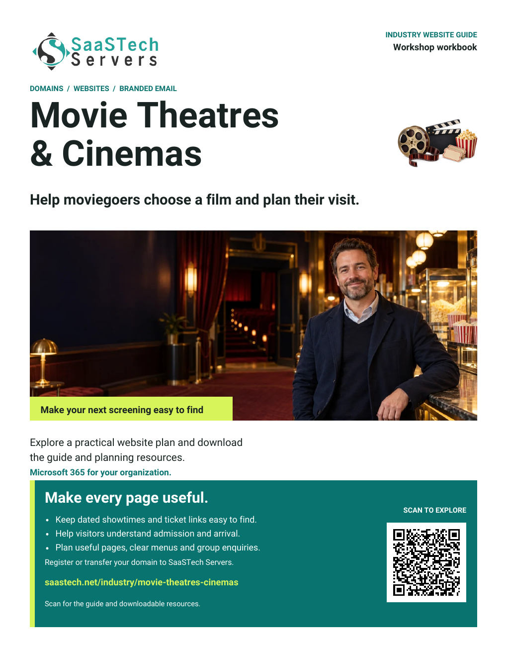


Getting started with SaaSTech
Create your free account before contacting support. Keep the detachable record private.
1 Create or sign in to your account
Use an email you can access and follow the secure account prompts. No purchase is required.
2 Keep your customer number and call-in PIN ready
Support may ask for both during a call you initiated through verified Contact Us.
3 Enable two-step verification
Have your registered phone or authenticator device with you when calling SaaSTech; you may need it to sign in or verify the account yourself.
Create My Account | saastech.net/create-account
Contact Us   | Account Learning Centre   | Delegate access playlist  
On Contact Us, check your language/region and currency settings, then use the local contact number shown there.
The Account Learning Centre covers setup and delegation for Website Builder and other services. Choose Work with delegates.
Cut or tear out the card below before sharing this workbook
PRIVATE account reference and call-in authentication
Organization or name | ____________________________________
Account sign-in email | ____________________________________
Customer number | ____________________________________
Call-in PIN | ____________________________________
Domain names | ____________________________________
Reviewed on | ____________________________________
Update your call-in PIN at pin.saastech.net or in My Account after signing in.
Never share your account password or call-in PIN with someone helping manage your services. Each helper should create their own SaaSTech account and receive only the delegated permissions they need. Review purchase/payment and account-security permissions carefully.
For official support, give the call-in PIN only during a call you initiated through verified Contact Us. Never share passwords, sign-in verification codes or recovery codes.
Do not record passwords, verification/recovery codes, security answers or payment details here. Keep this card safe and cut or tear it out before sharing the workbook.
Use a secure password manager for passwords and recovery information.
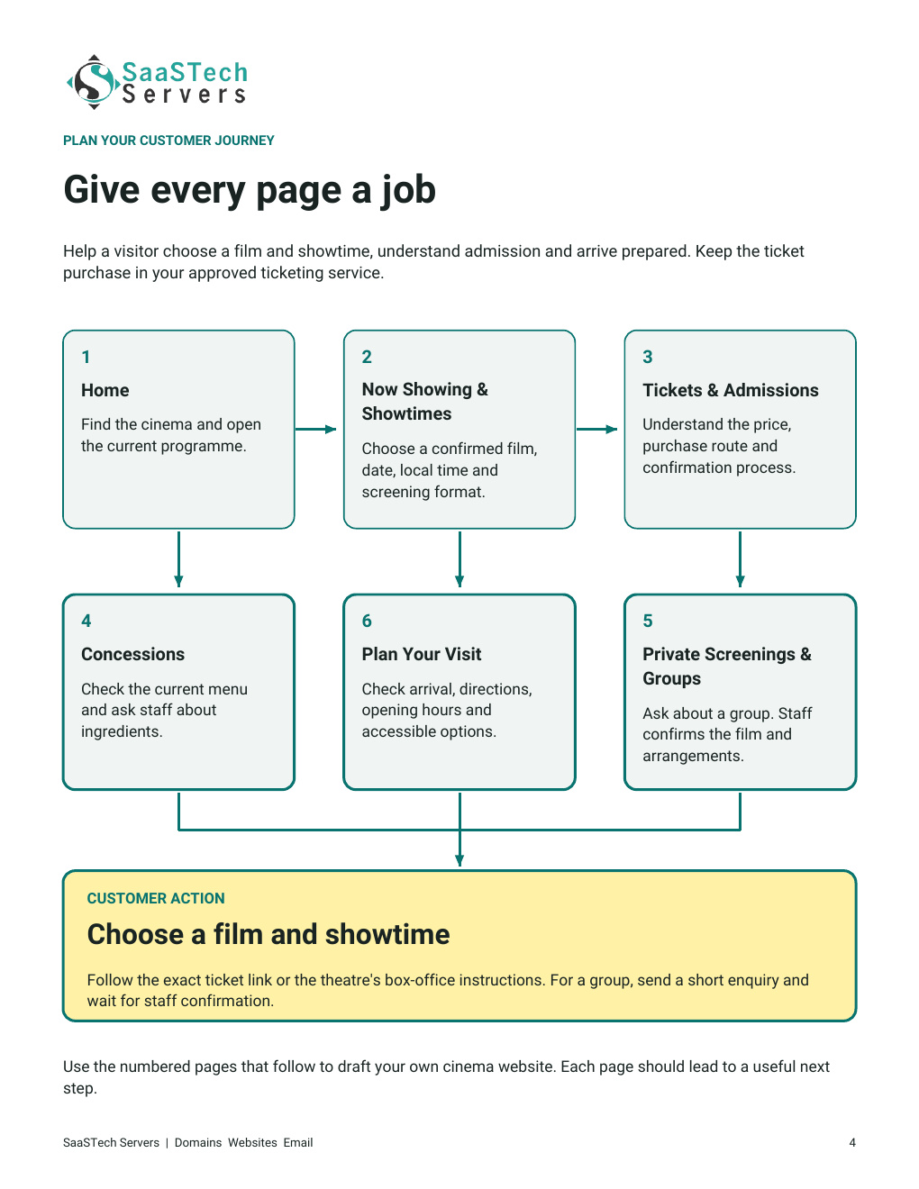

[1] 2 3 4 5 6

Home
Help moviegoers find the current programme quickly.
Introduce your cinema and the community you serve. Use an original photograph of your theatre, with one clear route to the current programme.
Gather your approved content
[ ] Your approved cinema name, community and original theatre photo.
[ ] A maintained link to Now Showing & Showtimes and current closure notices.
[ ] A short welcome and a visible location or visitor-information link.
Website Advice Put your main customer action near the top. A visitor should not have to watch a video before finding showtimes.
Our one-sentence welcome
________________________________________________________________________
Our main button label and destination
________________________________________________________________________
Our photograph and permission owner
________________________________________________________________________
Before you move on
Ask someone to find the current programme from the Home page on a phone.

1 [2] 3 4 5 6

Now Showing & Showtimes
Help customers choose one confirmed screening.
Organize current films by date. Give every screening a complete date and local time, with the information needed to choose confidently.
Gather your approved content
[ ] Approved film title, artwork or trailer permissions, runtime and classification.
[ ] Confirmed dates, local times, language and screening format.
[ ] Screening-specific caption or audio-description options and the exact ticket link.
Website Advice Remove expired screenings promptly. Never label a general film trailer or an unconnected calendar as a live ticket service.
Film information we can publish and who approves it
________________________________________________________________________
Our showtime update owner and review schedule
________________________________________________________________________
The exact screening-to-ticket link to test
________________________________________________________________________
Before you move on
Follow a film to its date, time and correct ticket destination; check the language and format.

1 2 [3] 4 5 6

Tickets & Admissions
Explain how a customer buys admission and knows it is confirmed.
Show current admission categories and explain the theatre's approved purchase process. Keep live inventory, seat selection and payments in the ticket system.
Gather your approved content
[ ] Verified admission categories, prices, taxes or fees and approved age rules.
[ ] Current box-office information and the theatre's existing ticket provider.
[ ] Approved refund, exchange, companion and purchase-confirmation information.
Website Advice Website Builder is not automatically a ticketing or reserved-seat system. Link to your existing approved service and explain the next step.
Our purchase route and confirmation wording
________________________________________________________________________
Prices or policies needing staff approval
________________________________________________________________________
Our ticket-provider and box-office contact routes
________________________________________________________________________
Before you move on
Compare the published price, fees and policy wording with the approved ticket service.

1 2 3 [4] 5 6

Concessions
Help visitors understand the current food and drink options.
Use your own product photographs and current menu details. Make prices and portion or combo information easy to read, and explain how staff can answer questions.
Gather your approved content
[ ] Current concession categories, items, sizes and prices the team can maintain.
[ ] Original food and drink photographs with useful alternative text.
[ ] Staff-approved ingredient, allergen enquiry and outside-food guidance.
Website Advice Invite an ingredient question without promising that an item is suitable for every person. Staff should confirm the current information.
Our menu categories and items to feature
________________________________________________________________________
Our price and menu review owner
________________________________________________________________________
How customers can ask an ingredient question
________________________________________________________________________
Before you move on
Review every menu item and price with staff, then check the menu at a phone-sized view.

1 2 3 4 [5] 6

Private Screenings & Groups
Turn a group idea into a useful enquiry for staff review.
Explain the group visits, school outings, private screenings or auditorium hire you genuinely offer. Make the difference between an enquiry and confirmation clear.
Gather your approved content
[ ] Verified capacity, lead times and offered group or private-screening options.
[ ] A staff-reviewed route for film permissions, availability and pricing.
[ ] A short enquiry asking for basic contact details, a preferred date and approximate group size.
Website Advice A form or appointment request does not reserve the auditorium or license a film. Staff must confirm permissions, availability and the agreed arrangements.
The types of groups we can help
________________________________________________________________________
The minimal information our enquiry needs
________________________________________________________________________
Our staff review and confirmation sequence
________________________________________________________________________
Before you move on
Check that the acknowledgement promises only receipt, not a screening, price or booking.

1 2 3 4 5 [6]

Plan Your Visit
Make arrival and visitor support easy to understand.
Show verified directions, opening and box-office hours and arrival guidance. Describe the accessible options that your theatre can actually provide.
Gather your approved content
[ ] Current address, parking or transit details, hours and a monitored contact route.
[ ] Verified accessible routes, seating and hearing-support arrangements.
[ ] Confirmed sensory-friendly sessions, if offered, and a route back to the selected film.
Website Advice Describe access options precisely and let visitors ask a question. Do not collect health information or private access requirements through a general public form.
Our arrival information and opening hours
________________________________________________________________________
Access and visitor support details to verify
________________________________________________________________________
Our contact route and return link to showtimes
________________________________________________________________________
Before you move on
Ask a new visitor to choose a film, plan arrival and find a way to ask for help.

